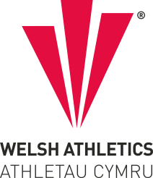

OPPORTUNITIES TO REPRESENT WALES AT MASTERS LEVEL IN 2026

Once again in 2026, Welsh Athletics are providing a number of opportunities for Master athletes to represent Wales in Internationals across all distances from 5km through to marathon and following the success of the Trail Half Marathon this year we will be repeating it again in 2026. As last year in addition to competing against England in all of the fixtures we will hope for even more competition from Northern Ireland and the Armed Forces in some of the matches.

Athletes have to be eligible to compete for Wales and registered athletes in Wales. It is expected that all athletes competing for Wales would take part in at least one Welsh Championship in the preceding or current year.
Master International Opportunities 2026

5km - Shrewsbury Festival of Sport - 11/07/2026
10km - Bideford 10km - 10/05/2026
Half Marathon - Swansea ½ Marathon - 07/06/2026
Marathon - Manchester Marathon - 19/04/2026
Trail ½ Marathon - Forest of Dean - 27/09/2026
Teams of up to 6 male and 6 female athletes will be selected in FIVE year age groups across all distances. We will also be including 70+ teams in all of the fixtures. In road events athletes are required to meet the minimum standards as follows:
Minimum Welsh Standards 2026

 | 35-39 | 40-44 | 45-49 | 50-54 | 55-59 | 60-64 | 65-69 | 70-74 | 75+
5KM
Men | 16-00 | 16-30 | 17-00 | 18-00 | 19-00 | 20-00 | 21-00 | 24-00 | 26-00
Women | 19-30 | 20-00 | 21-00 | 22-00 | 23-30 | 24-30 | 27-30 | 30-00 | 33-00
 | 35-39 | 40-44 | 45-49 | 50-54 | 55-59 | 60-64 | 65+
10KM
Men | 33-30 | 34-30 | 36-00 | 37-30 | 39-30 | 41-00 | 45-00 | 47-30 | 52-00
Women | 41-00 | 42-30 | 44-00 | 45-30 | 47-30 | 50-00 | 57-30 | 62-30 | 67-30
 | 35-44 |  | 45-54 |  | 55-64 |  | 65+
1/2 MARATHON
Men | 75-00 | 77-30 | 80-00 | 85-00 | 90-00 | 95-00 | 1hr45 | 1hr55 | 2 hrs05
Women | 89-00 | 93-00 | 96-00 | 1hr40 | 1hr45 | 1hr54 | 2hr10 | 2hr20 | 2hr30
 | 35-44 |  | 45-54 |  | 55-64 | 65+
MARATHON
Men | 2-45 | 2-50 | 3-00 | 3-10 | 3-20 | 3-40 | 4-00 | 4-15 | 4-30
Women | 3-20 | 3-30 | 3-40 | 3-50 | 4-00 | 4-15 | 4-30 | 5-15 | 5-30

Athletes are expected to pay their own race entry fees, make and fund their own travel and accommodation arrangements for Manchester. All athletes representing Wales for the first time are entitled to a free Welsh vest and are entitled to purchase a kit package.

PLEASE only express an interest if you are available on the date of the event. Whilst we accept athletes get injured between expressing an interest and selection, we have had a number of late withdrawals due to change of availability. This often results in others missing out on an opportunity.

Expressions of interest for the international matches will be sought on a race by race basis as some athletes expressed an interest across all races last year and after selection then declared themselves unavailable.

Swansea Half Marathon
If you are interested in competing for Wales at the Swansea University Swansea Half Marathon on Sunday 7th June 2026, please complete the Expression of Interest Form via the following link:
https://forms.office.com/e/TUCAw5gUFz or QR Code

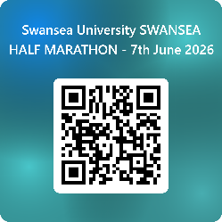

Bideford 10km
If you are interested in competing for Wales at the Bideford 10km on Sunday 10th May 2026, please complete the Expression of Interest Form via following link:
https://forms.office.com/e/geRJPUvrr1 or QR code

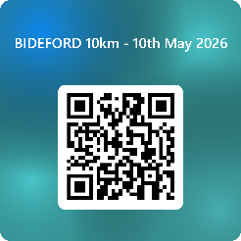

Shrewsbury Festival of Running
If you are interested in competing for Wales at the Shrewsbury Festival of Running on Saturday 11th July 2026, please complete the Expression of Interest Form via the following link:
https://forms.office.com/e/CgQiZsyZhT or QR code



Forest of Dean Trail Half Marathon
If you are interested in competing for Wales in the Forest of Dean Trail Half Marathon on Sunday 27th September 2026, please complete the Expression of Interest Form via the following link:
https://forms.office.com/e/gztAE8u8y0 or QR code

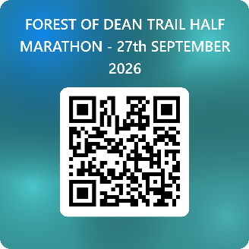

Further details of all of the International Programme, are available from Bernie Jones at Bernie-jones@sky.com or 07919043117

Selection dates for teams will be as follows:
Marathon - 18/12/2025
Half Marathon - 15/4/2026
10km - 15/4/2026
5km - 10/6/2026
Trail ½ Marathon** - 19/8/2026

**Please note that the first two finishers in each age group at the Bwstfil y Bryn Trail Race (10.5mile route) on 17th August (Welsh Masters Championship) will automatically be selected for the Trail Half Marathon International if they are interested.

There is no obligation to fill all available positions.

The selection panel will consist of members of the Welsh Athletics Masters Advisory Group.

Appeals Process
There shall be no right to appeal the selection of the Welsh team made by the selection panel.

De-selection Process
De-selection of an athlete may occur following:
1. Failure to adhere to the Welsh Athletics code of conduct
2. In the event of an athlete sustaining an injury or illness following acceptance of their position on the team, they are required to inform the Team Manager immediately.

Equal Opportunities
Welsh Athletics will not discriminate in the selection of any athlete on the basis of any protected characteristics.

Amendment
Welsh Athletics reserves the right to amend this selection policy at its sole discretion and will make any amended version publicly available (including the date on which the amendment was made) on the Welsh Athletics website

Further details or information is available from Bernie Jones Bernie-jones@sky.com or 07919043117

